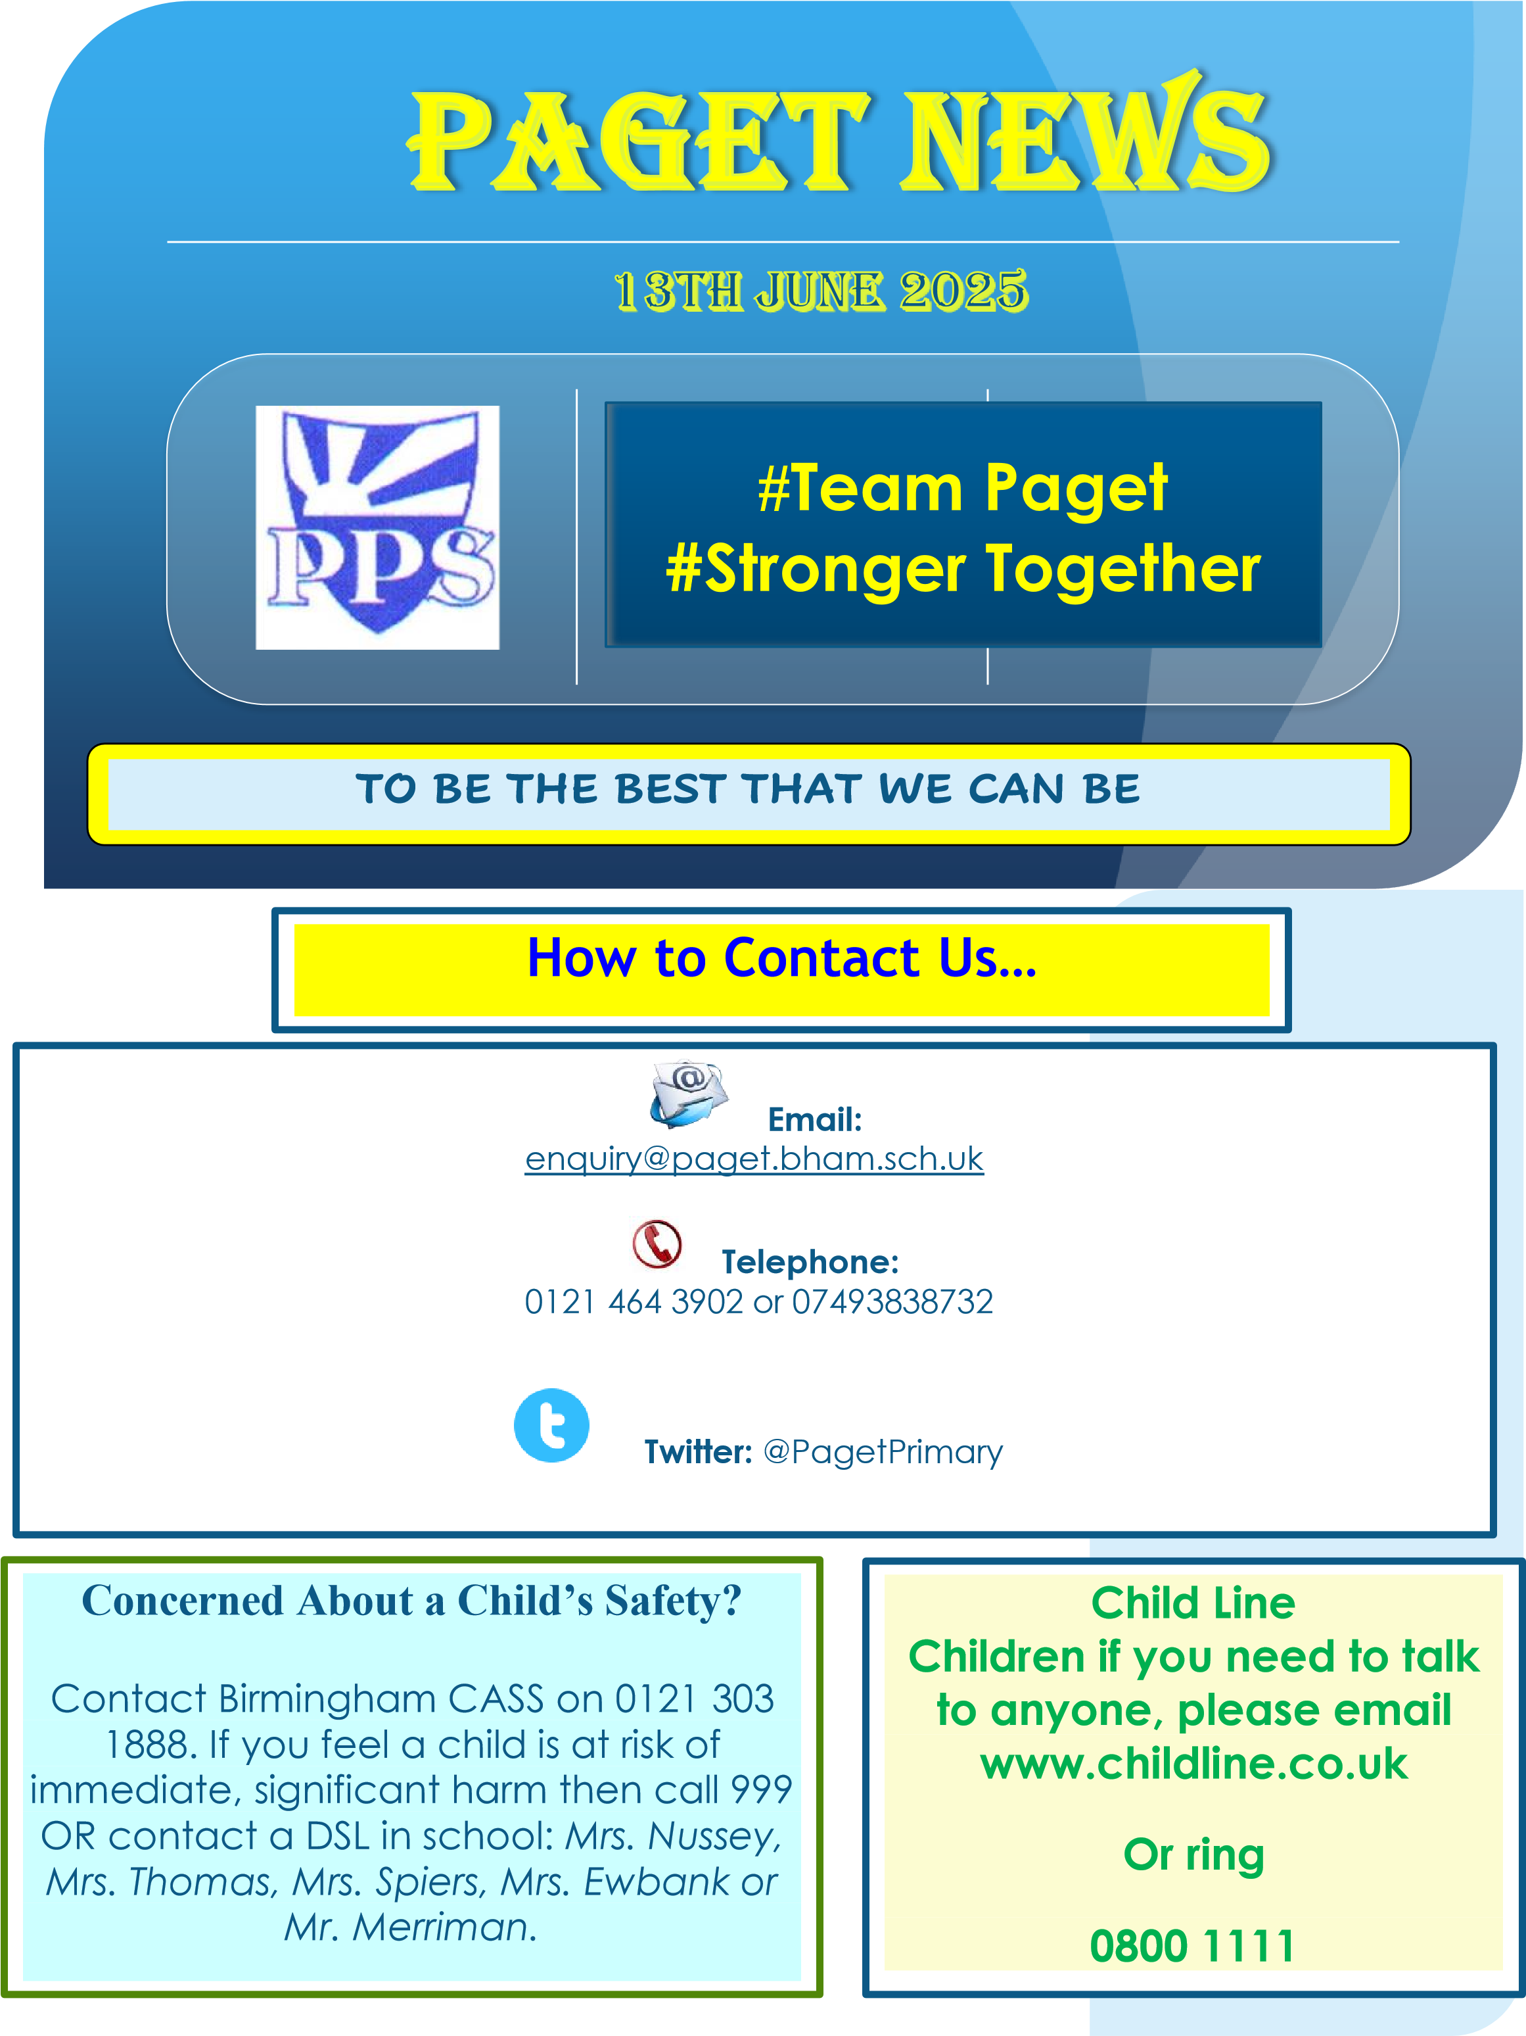

18th July 2025

**It is hard to believe that we are now at the end of the summer term. We have had a very busy year.**

**Paget Team Welcome**

**It has been lovely, this week to reflect on what the children have achieved.**

**In the Year 6 production, the children talked about their fond memories of being at Paget Primary School.**

**The children also talked about their fantastic residential that took place last week. They loved being in a castle.**

**All the staff came back from the trip saying how much they enjoyed the whole trip.**

**We would like to wish our Year 6 children every success and happiness in their next step and congratulations on their SATs achievements.**

**Last week, Reception also went on a trip to Dudley Zoo. The children and staff all had a great time. The children really liked seeing a variety of animals. The flamingos were a real hit!**

**Well done to all our children who have achieved 100% attendance.**

**The children enjoyed a visit to Scallywags or Woodlands.**

**All the children had a great time.**

**Let’s hope that next year, we can send a greater number of children on the attendance trips.**

**This week, we say goodbye to two members of staff.**

**Mrs Davies, teacher, is moving to Sheffield with her family.**

**Mrs Holmes, TA and Forest Schools lead, is moving to a new school.**

**We would like to take this opportunity to thank Mrs Davies and Mrs Holmes for all their hard work and commitment to Paget. We will miss them and wish them every happiness for their future.**

**Thank you to all of our school team for their hard work over the year.**

**We hope that you all have a wonderful summer holiday and look forward to seeing you in September.**

**Learners of The Week**

Nursery – all of Cubs

Tigers Alice and Yusuf Leopards Arslan and Demi-Rose

1D Harrison and Daria 1P Kheyam and Oriche

2D Godfrey and Precious 2W Aleyah and Zane

3C Zylah and La’Sharn 3H Kiaus and Ryan

4C Razaan and Darcie 4W Ellie and Arnie

5B Subhan and Amia 5R Amelia and Vaddym

6B Jasmine and Logan H 6B Riah and Cameron

Panthers, Pumas and Lions Leon and Eman



**Housepoints**

**Winning Class EY/KS1 1P**

**Winning House EY/KS1 Venus**

**Winning Class KS2 6E**

**Winning House KS2 Saturn**

**This year, the overall winning house is Venus – well done!**

**Mercury are second place**

**Reminder:**

**We return to school on 3rd September 2025.**

**If your child is starting Nursery, they will join us the week of 8.9.25. Your letter will inform you of your child’s start date.**

**If your child is Reception, the current Nursery children all start 3.9.25, If you are new to us, your letter will inform you of your child’s start date.**

**Ipads:**

**All children in Years 1-6 will be taking home their ipads. There will be limited access time and apps.**

**Please ensure that the ipad is kept in good working order over the holiday. The ipads will continue to be monitored over the holiday. Any inappropriate use will be flagged and contact may be made from ATLP.**

**If your child moves school over the summer, please return the ipad to us in September.**

**Thank you for your support with the ipads this year. The children have enjoyed using them to enhance their learning.**

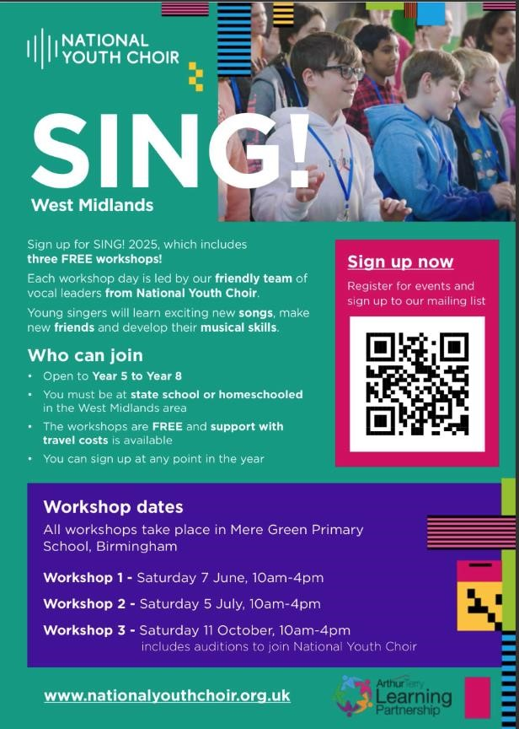

# **DATES FOR YOUR DIARY**



**2024-2025**

**Friday 18th July - last day of term - break up for the Summer**

**Monday 21st July - School closed to children - Teacher training Day**

**2025-2026**

**Monday 1st September - Term begins but school closed to children - teacher training day**

**Tuesday 2nd September - School closed to children - teacher training day**

**Wednesday 3rd September - Children return to school**

**Thursday 23rd October - children break up for half term**

**Friday 24th October - school closed to children - teacher training day**

**Monday 3rd November - Children return to school**

**Monday 1st December - school closed to children teacher day**

**Friday 19th December - break up for Christmas holidays Monday 5th January - school closed to children - teacher training day**

**Friday 13th February - break up for half term**

**Monday 23rd February - school closed to children - teacher day**

**Friday 27th March - children break up for Easter holidays**

**Monday 13th April - term begins**

**Friday 1st May - school closed to children - teacher training day**

**Friday 22nd May - break up for half term**

**Monday 1st June - term begins**

**Friday 17th July - children break up for the summer**

**Monday 20th July - school closed to children - teacher day**

**This section will be regularly updated once new dates are known and confirmed.**

**\*Indicates newly added or changed items**